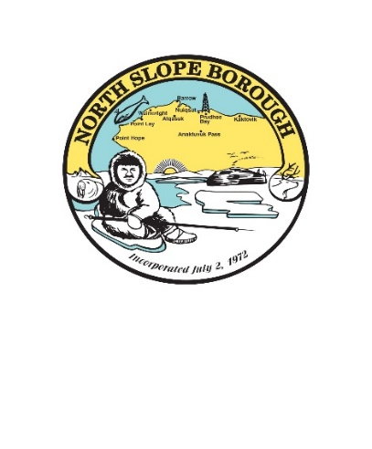
North Slope Borough Oil and Gas Forum 2025
Atautchimuglugi nunat, iñuuniaġniq suli uunnaagutivut
“Linking Lands, Lives, and Energy”
Marriott Anchorage Downtown
August 25-26

MONDAY, AUGUST 25
8:00am Registration Table Open
9-10am Invocation and Opening Remarks
- Welcome
Chastity Kayutak Olemaun, NSB Director of Planning & Community Services, introduces Co-Emcees Angela Cox, Director, NSB Department of Government Affairs, and Jason Brune, Director, NSB Department of Environmental Management
- Invocation – NSB Assembly Member Eva Kinneeveauk
- Opening Remarks
  - Mayor Josiah Patkotak, North Slope Borough
  - Governor Mike Dunleavy, State of Alaska
  - Lt. Governor Nancy Dahlstrom, State of Alaska
  - Senator Lisa Murkowski, Alaska – Recorded Remarks
  - Senator Dan Sullivan, Alaska – Recorded Remarks
  - Representative Nick Begich, Alaska – Recorded Remarks
10-10:15am Break
10:15-11:00am Oil & Gas Financial Outlook: State of Alaska and North Slope Bourgh
- Fadil Limani, Director, NSB Department of Finance
11:00-11:30am Federal, Local and State Update
- Kara Moriarty, Senior Advisor for Alaskan Affairs, US Department of the Interior
- John Boyle, Commissioner, Alaska Department of Natural Resources
- Chastity Olemaun, Director, NSB Department of Planning & Community Services
11:30am-1pm Lunch Keynote Sponsored by Santos - Message by Nagruk Harcharek, VOICE of the Arctic
1:00-2:30pm Oil & Gas Industry Update
- Erec Isaacson, President, ConocoPhillips Alaska
- TBD, Hilcorp
- Joe Balash, Vice President of External Affairs, Santos
2:30-3:00pm Break
3:00-4:30pm Mitigating Impacts to Subsistence Use
Moderator: Harry Aiken, PBU Regional Supervisor, NSB Department of Public Works
- Brian Person, NSB Department of Wildlife Management
- Herbert Ipalook, Sr., Nuiqsut
- Herbert Kinneeveauk, III, Alaska Eskimo Whaling Commission
- Tara Sweeney, Vice President of External Affairs, ConocoPhillips Alaska
4:30pm Closing Remarks
  - Chastity Kayutak Olemaun, Director, NSB Department of Planning & Community Services
5:00-6:30pm Meet and Greet Reception and Entertainment – Mayor’s Office and Staff

TUESDAY, AUGUST 26
8:00am Registration Table Open
8:30-9:00am Invocation and Opening Remarks
- Welcome
  - Representative Robyn Burke, House District 40
  - Senator Jesse Bjorkman, State of Alaska
- Invocation:
  - NSB Assembly Member Carla Sims-Kayotuk
9:00-10:15am Planning for Transportation and Utility Corridors
Moderator: Nagruk Harcharek, President, VOICE of the Arctic
- Hina Kilioni, Deputy Director, NSB Department of Port Authority
- Inuuteq Stotts, ASRC Consulting and Environmental Services
- Jeff Bruno, ASTAR Coordinator, Alaska Department of Natural Resources
- Stephanie Kuhns, Acting Alaska’s District Manager, Bureau of Land Management
- Fredrick Brower, ICAS
10:15-10:30am Break
10:30am-12pm Eastern and Western Expansion
Moderator: Jason Brune, NSB Department of Environmental Management
- Taqulik Hepa, Director, NSB Department of Wildlife Management
- Brandi Sellepack, Manager, Exploration, ConocoPhillips Alaska
- Charles Lampe, President, Kaktovik Inupiat Corporation
- Doreen Fogg-Leavitt, ICAS
12:00-1:30pm Lunch Keynote Sponsored by Conoco Phillips Alaska
1:30-2:30pm Data Centers
Moderator: TBD
2:30-3:00pm Closing Remarks
- Mayor Josiah Patkotak, North Slope Borough
3:00-4:00pm QR Survey of 2025 NSB Oil and Gas Forum

